API TESTING INTERVIEW QUESTIONS

1. What are Micro services?
2. How to write Test cases for API Testing?
3. Debugging in API Testing?
4. REST and SOAP Services?
5. Web Services and Backend Services?
6. What is the use of JAVASCRIPT Snippets? And why do you use it in API Testing?
7. All the HTTP methods used in API testing?
8. What is Path and Query Parameter?
9. What exactly need to be verified in API Testing? 10.Difference Between POST and PUT Method?
10. What is meant by Collection creation in Postman? What is assertion in Postman?
11. How were you validating the JSON Response? 13.In your project where did you Perform API testing? 14.API Testing Process?

15.What is JSON Schema? 16.Difference between URL and URI?

1. Difference between HTTP and HTTPS?
2. Which Services will you prefer (SOAP or REST) and why?

* qa actions after getting requirement’s
* api testing in your project
* difference between put and patch
* validation in api
* environment for dev and qa
* runtime polymorphism
* method over riding
* What is the role in your project
* What is Encapsulation
* What is agile
* What is Retrospective meeting
* Java script
* Difference between Put and Patch
* Told one Scenario and told to explain about Api Process in That Scenario
* json validation format

***ANSWERS:***

1. Microservices are an architectural and organizational approach to software development where software is composed of small independent services that communicate over well-defined APIs. These services are owned by small, self-contained teams.
2. a) Validate the keys with the Min. and Max range of APIs (e.g maximum and minimum length)
   1. Keys verification. If we have JSON, XML APIs we should verify it’s that

all the keys are coming.

* 1. Have a test case to do XML, JSON Schema validation.
  2. Verify the Parse the Response data
  3. Verify the JSON Schema validation, Verify the Field Type, Verify the Mandatory Fields
  4. Valid Response headers & Negative Testcases response
  5. Verify that how the APIs error codes handled.
  6. Verify the response HTTP status code.

1. a) Get Information on the Request and Response
   1. Identify the Problem Area
   2. Discuss with the development team members if server error
   3. Debug and Resolve
2. SOAP API: 1. SOAP Stands for Simple Object Access Protocol, it’s an architecture 2. SOAP is not as simple as REST API 3. It supports only the XML format 4. It consumes more bandwidth 5. The size of the response will be more 6. The response time will be more than REST API 7. We use generic protocol and it’s not secure

REST API: 1. REST Stands for Representative State Transfer, it’s a representation 2. REST seeks to fix problems to SOAP and provides simple methods of accessing Web services 3. It supports various formats like JSON, XML, Text, HTML etc 4. It consumes Less bandwidth 5. The size of the response will be Less 6. The response time will be lesser than SOAP API 7. We use HTTPS protocol and its more secure

1. Web Services: Web service is a collection of open-source protocols and standards used for exchanging data between systems or applications

whereas API is a software interface that allows two applications to interact with each other without any user involvement.

Backend Services: The backend service configuration contains a set of values, such as the protocol used to connect to backends, various distribution and session settings, health checks, and timeouts.

1. Snippet is a programming term for a small region of re-usable source code, machine code, or text. JSON Snippets are snippets that contain pieces of JSON data instead of HTML.
2. POST, PUT, GET, PATCH, DELETE, HEAD
3. The path parameter defines the resource location it has / symbol, while the query parameter defines sort or filter operations, and it has? Symbol.
4. *Data accuracy

*HTTP status codes

*Response time

*Error codes in case API return any errors

*Authorization checks

*Non-functional testing such as performance testing, security testing

1. Both POST and PUT http methods works similar as it is used to edit or modify the resource which is already available in the server or database but while using PUT method if we give all the parameters key and value pair and if there is no resource in the database it will give error response. But in terms of PATCH method, it will not create a new resource but will provide error.
2. Collection creation is a package in which we can save any number of individuals requestions for specified http request and will use runnable to run the requests at a time.

Assertions checks weather the given predict in the tests result is true or false, in any programming language the assertion predictions are a Boolean expression.

1. * We monitor API responses and ensure that the format that we are getting is same as the expected one.

* We get alert whenever there is any breaking change in JSON response.
* We use JSON Schema to construct a model of API response and it makes easier to validate that API is returning the valid data.

1. Integration scenario for ivalidate application:

* API user services end point to create blank contract entity
* Once after creating the contract, it provides the contract ID in the JSON Response, the same contract ID we should pass as a query parameter to provide the exclusion details. Exclusion details is a separate end point here we must pass two set of parameters, one for data-based exclusion and another for date-based exclusion, once this end point becomes successful it generates Contract entity ID
* The same contract entity ID we should pass as parameter for run exclusion job end point. Based on its successful execution we can generate the reports
* In order to generate the particular report, I have to use a specific end point (HTTP URL) for that URI, I need to pass exclusion job ID as a query parameter then only the reports will be generating in a specific location, the data available in the report manually I need to check the database

1. *The developer will provide the end point, Path parameter (/ symbol) and Query parameter (? Symbol)

*We need to click send request and we receive the response in different format if JSON selected

*We get response status code

*We need to verify the response status code

*We can see the response time(millisecond)

*We will see the response size(bytes)

*Authorization checks

1. JSON Schema is a contract for JSON document that defines the expected data types and format of each field in the response

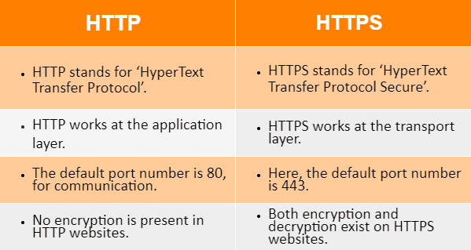

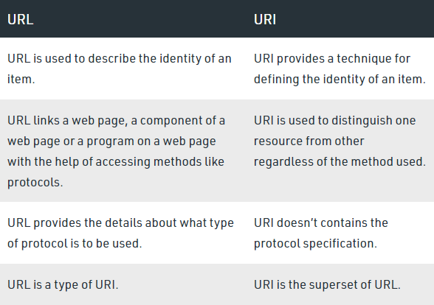

1. We prefer REST API because of the following reasons:

* REST provides simple methods of accessing Web services
* It supports various formats like JSON, XML, Text, HTML etc
* It consumes Less bandwidth

*The size of the response will be Less

*The response time will be lesser than SOAP API

*We use HTTPS protocol and its more secure